Introduction
NOTE: This assignment was based on a student submission from 2015. The original document scored 75%. Changes have been made to the content, formatting and referencing to fix a number of identified issues. The current version shown here would have scored 100% using the given marking key.
Trace elements are elements that are present in miniscule amounts in a particular sample or in the environment. A few examples of trace elements include: chromium, copper, cobalt, iron, manganese and molybdenum. They are necessary for the normal growth and developments of organisms, and effects of not enough trace elements include stunted growth and, in severe cases, death ('Trace Elements', 2015). The main sources of these elements come from the soil in which our food is grown as well as our main source of food grazing amongst the source. These elements can be tested for in the soil using methods such as atomic absorption spectroscopy to increase the efficiency of crop yield and health safety for animals grazing on designated pasture. Atomic absorption spectroscopy (AAS) is a useful method in detecting the presence of trace elements in low concentrations due its low detection limits (Schiller, 2010).
Introduces atomic absorption spectroscopy as an analytical technique that can be used to measure levels of trace metals
Introduces trace metals. Gives enough background to the reader to explain the importance of analysing trace metals.
Uses clear headings to divide content into sections
Atomic absorption and emission
Atomic absorption spectroscopy is an analytical method used for testing unknown mixture samples based on the emission and absorption of characteristic wavelengths of light. By comparing the amount of light absorbed by different samples, AAS accurately deduces the concentration of an element in an unknown sample. The method is able to produce results that can be translated into a calibration graph for an accurate result of how much concentration of an element is present in the tested sample.
Gives overview of AAS method and principles.

The method is reliant on the concept of ‘excited’ electrons and electrons entering the ground state. When electrons are excited, they absorb light in certain wavelengths depending on how many energy shells the excited electron has ‘jumped’ up to as well as how many electrons are involved in the process. Electrons entering the ground state emit unique wavelengths of light as it re-enters the ground state (excited electrons jumping back down to their original shells in-which they jumped from) (Smith, Davis, Disney, Hayes & Whan, 2014).
Elaborates on principles of emission and absorption. Correctly uses subject-specific terminology such as “excited”, “ground state”, “wavelengths”.

Could improve answer with a diagram showing emission/ absorption

Atomic absorption spectrometers
Gives a brief overview of instrument parts and refers reader to Figure 1
AAS is performed using an instrument called an atomic absorption spectrometer - the instrument consists of five main components; a hollow cathode lamp, a burner where the sample solution is sprayed into a flame - or also known as a flame atomiser (turns samples into mists or aerosols), diffraction grating or a monochromator, a photomultiplier, and the output display (Figure 1).
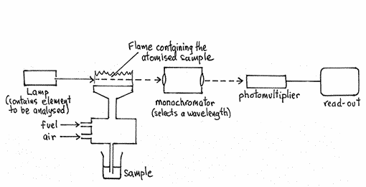
Underneath the image is a figure caption containing a description of the image and an in-text reference for the image’s source
Figure 1 is placed near the text that referred to it. The image is relevant to the topic and large enough to read easily
Figure 1: Simplified diagram of an atomic absorption spectrometer (NSW HSC Online, n.d.).
The first section of the atomic absorption spectrometer contains a hollow cathode lamp and an atomiser. The hollow cathode lamp contains the gaseous state of the element to be analysed or tested for presence in the unknown tested sample. The element in the hollow cathode lamp has electrical pulses run through it causing the lamp to emit light (Wikipedia, 2013). The atomiser converts the unknown sample into an aerosol or mist which is then sprayed into the flame (Garces, n.d.).

If the chosen element is present in the unknown sample then the unknown sample will absorb the light emitted by the hollow cathode lamp. The reason why the wavelengths of light emitted by the element in the hollow cathode lamp are absorbed by the ground state atoms of the unknown sample is because the electrons are on the same energy levels. The more light is absorbed, the higher the concentration of the element will be in the unknown sample (Smith, Davis, Disney, Hayes & Whan 2014).
Discusses each of the parts of the machine one at a time. Uses in-text referencing correctly.

The light which passes through the flame unabsorbed is then received by the monochromator or a prism and filters out a specific wavelength of light. Samples containing more of the chosen element will have less light at that particular wavelength than a blank sample. (Zbigniew, n.d.). After the light has been through the monochromator or is filtered out by a prism, the light is then picked up by the photomultiplier (a light-sensitive device) and has its current amplified by up to 100 million times (Wikipedia, 2015). The current amplified by the photomultiplier is then received by the last component of the atomic absorption spectrometer, the output display or readout.
Calibration graphs resulting from experiments performed via AAS can tell the wavelengths of light absorbed in the test and the concentration of how much light was received by the detector. In order to find the specific concentration of a trace element in an unknown sample the scientists would need to cross-reference with known data about wavelengths absorbed by that particular element and they can then draw a line from the corresponding absorbance to the drawn calibration graph produced by the experiment to find the concentration of the trace element in ppm (parts per million). An example of a typical calibration curve is shown in Figure 2.

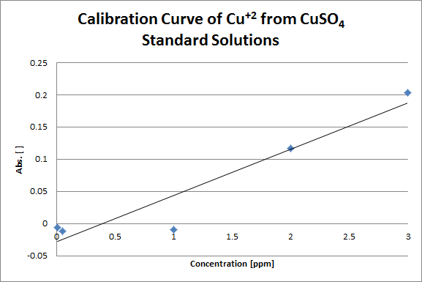
Explains how the results are used to form calibration graphs. Includes a calibration graph for a heavy metal (which was the topic of the paper).
Figure 2: Calibration curve of concentration of Cu²⁺ from CuSO₄ (Note: No apparent variation of concentration is present) (Novy, 2012).

Detecting trace elements in soils
Introduces section about trace elements in soils by explaining importance of tracemetals
Detection of trace elements in soil is important as they can affect the yield of crops for farmers and suitability for cattle grazing as well as other agricultural related situations. Deficiencies of trace metals can affect crop growth. For example, legumes cannot grow in soils of arid parts of Victoria, Australia, and maintenance of animal health can be of issue on pastureland that suffers cobalt deficiency.

Trace metals such as molybdenum can be analysed using AAS. In this process, the analysts would be required to have an amount of soil sample to be atomised by the atomiser. A hollow cathode lamp containing molybdenum would be used and electricity would be run through the lamp so that it emits wavelengths of light characteristic to molybdenum (Figure 3). Presuming the soil sample has traces of molybdenum present, the light emitted from the hollow cathode lamp would be absorbed by atoms of molybdenum in the sample, reducing the amount of light reaching the monochromator and photomultiplier. The wavelength of light that needs to be measured is chosen based on the wavelengths of light emitted and absorbed by the atom. For molybdenum, wavelengths of 313.3 nm or 320 nm are chosen (Flame Atomic Absorption Spectrometry, 2015).
Selects one trace metal in particular to focus on: molybdenum.

Explains AAS procedures using molybdenum specifically (e.g. refers to molybdenum hollow cathode lamp and wavelengths used for detecting molybdenum)
Uses previously-described process of calibration curves to explain how concentration of molybdenum would be found in an unknown sample
After repeating the analysis with samples of a known concentration of molybdenum, the analyst would be able to generate a calibration curve. This curve could be used to then find the concentration of traces of molybdenum in the unknown sample of the soil.

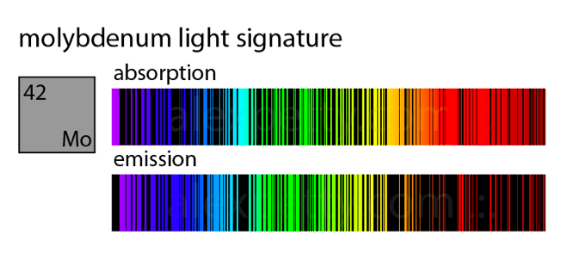
Gives emission and absorption spectrum that is specific to the chosen element (molybdenum)
Figure 3: Absorption and emission spectrum of molybdenum, (Gries Petty Research, 2015).

Conclusion
Atomic absorption spectroscopy is a powerful and accurate analytical method used to find the concentration of trace elements. AAS can find the concentration of the trace element the analyst is looking for in the unknown sample. It can find the concentration of the trace element by comparing the absorbance of the unknown sample to the absorbance of samples of known concentrations.
Conclusion summarises the main information from the report

References
Flame Atomic Absorption Spectrometry. (2015) (12th ed., p. 86). Mulgrave, Victoria. Retrieved from http://www.chem.agilent.com/Library/usermanuals/Public/0009.pdf
Garces, F. Atomic Absorption Spectroscopy: Instrumental. Miramar Chemistry. Retrieved 27 March 2015, from http://faculty.sdmiramar.edu/fgarces/LabMatters/Instrument.htm
All references follow APA formatting. All author details are correct.

The bibliography is sorted into alphabetical order and has a consistent font and formatting.

All entries have a hanging indent. This can be set using the ruler at the top of the page
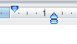

first line
indent

second
line indent

Gries Petty Research. (2015). Molybdenum Light Signature. Retrieved from http://alexpetty.com/content/images/2014/09/Figure-42--The-light-signature-of-Molybdenum.png
Novy, M. (2012). Cu⁺² AAS Calibration Curve. Retrieved from http://openwetware.org/images/1/10/Cu%2B2_AAS_Calibration_Curve.png
NSW HSC Online. Simplified Diagram of AAS Equipment. Retrieved from http://www.hsc.csu.edu.au/chemistry/core/monitoring/chem943/aasequipment.gif
Schiller, M. Atomic Absorption Spectroscopy (AAS). Easy Chem. Retrieved 27 March 2015, from http://www.easychem.com.au/monitoring-and-management/manufactured-products/atomic-absorption-spectroscopy-aas
Smith, D., Davis, A., Disney, A., Hayes, V., & Whan, R. (2014). Nelson Chemistry Units 1 & 2 For the Australian Curriculum (pp. 125-131). South Melbourne, Victoria: Cengage Learning Australia Pty Limited.
Trace Elements. (2015). Business Dictionary. Retrieved from http://www.businessdictionary.com/definition/trace-elements.html
Wikipedia. (2013). Hollow-cathode lamp. Retrieved 27 March 2015, from http://en.wikipedia.org/wiki/Hollow-cathode_lamp
Wikipedia. (2015). Photomultiplier. Retrieved 27 March 2015, from http://en.wikipedia.org/wiki/Photomultiplier
Zbigniew, P. Monochromator. Dr. Postawa Zbigniew Group. Retrieved 27 March 2015, from http://users.uj.edu.pl/~ufpostaw/2_Pracownia/S2/monochromator_en.htm

